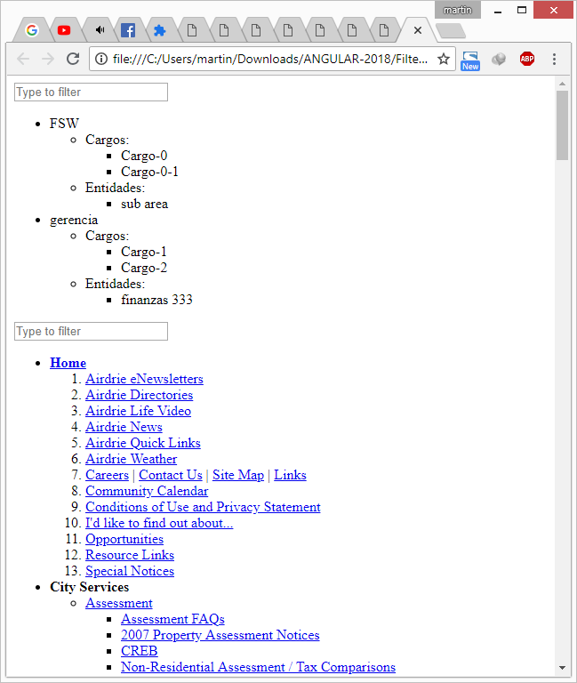

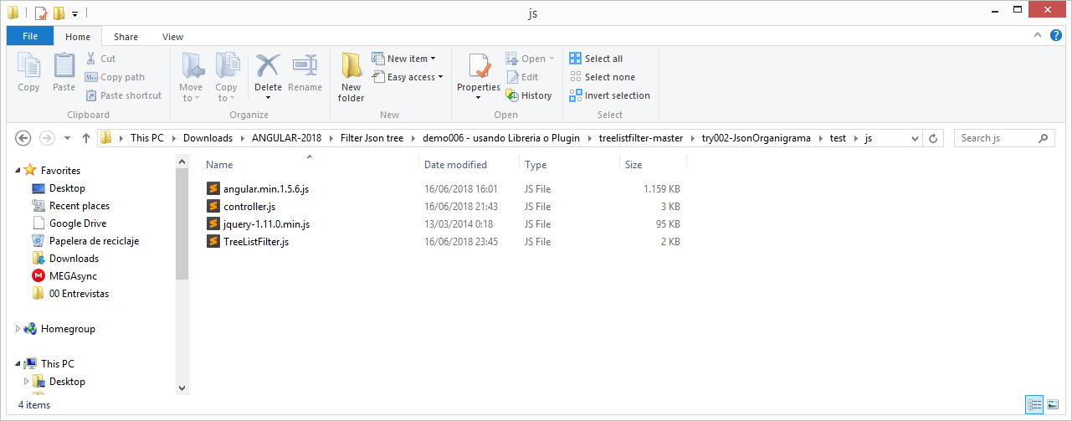

angular.min.1.5.6.js

jquery-1.11.0.min.js

Controller:

|  |
| --- |
| var app = angular.module("myApp", []);  app.controller("myController", function ($scope, $http) {  function getData() {  $scope.organigrama =  [  {  nombre: 'FSW'  , id: 2313  , Cargos: [{  info: {  idCargo: 23123  , nombreCargo: 'Cargo-0'  }  , colaboradores: [  { idColab: 1312, nombreColab: 'martin dq' }  , { idColab: 3122, nombreColab: 'Jose dq' }  ]  },  {  info: {  idCargo: 3111  , nombreCargo: 'Cargo-0-1'  }  , colaboradores: [  { idColab: 31233, nombreColab: 'Snatos dq' }  ]  }  ]  , Subareas: [  {  info: { nAreaId: 34123, nombre: 'sub area' }  , cargo: []  , Subareas: []  }  ]  }  , {  nombre: 'gerencia'  , id: 2233  , Cargos: [  {  info: {  idCargo: 23123  , nombreCargo: 'Cargo-1'  }  , colaboradores: [  { idColab: 31233, nombreColab: 'martin dq' }  , { idColab: 31233, nombreColab: 'Meramendi dq' }  ]  }  , {  info: {  idCargo: 23123  , nombreCargo: 'Cargo-2'  }  , colaboradores: [  { idColab: 31233, nombreColab: 'Peralta dq' }  , { idColab: 31233, nombreColab: 'Quinto dq' }  ]  }  ]  , Subareas: [  {  Cargos: []  , Subareas: [  {  info: { nAreaId: 12323, nombre: 'Sub area Nivel 3 x222 @' }  , Cargos: [  {  info: { idCargo: 23123, nombreCargo: 'cargo nivel 3' }  , colaboradores: [  { idColab: 312312, nombreColab: 'Pizarro j C.' }  , { idColab: 31312, nombreColab: 'Mandamiento Q M.' }  ]  }  ]  , Subareas: []  }  ]  , info: { id: 3123, nombre: 'finanzas 333' }  }  ]  }  ]  //end function  }  getData();  }); |

Tree filter:

|  |
| --- |
| /**  * Tree List Filter jQuery plugin 1.0  *  * Copyright (c) 2014, AIWSolutions  * License: GPL2  * Project Website: http://wiki.aiwsolutions.net/dOQKO  **/  jQuery.fn.treeListFilter = function (list, timeout) {  var list = jQuery(list);  var input = this;  var keyTimeout;  var lastFilter = '';  // Default timeout  if (timeout === undefined) {  timeout = 200;  }  function filterList(ulObject, filterValue) {  if (!ulObject.is('ul') && !ulObject.is('ol')) {  return false;  }  var children = ulObject.children();  var result = false;  for (var i = 0; i < children.length; i++) {  var liObject = jQuery(children[i]);  if (liObject.is('li')) {  var display = false;  if (liObject.children().length > 0) {  for (var j = 0; j < liObject.children().length; j++) {  var subDisplay = filterList(jQuery(liObject.children()[j]), filterValue);  display = display || subDisplay;  }  }  if (!display) {  var text = liObject.text();  display = text.toLowerCase().indexOf(filterValue) >= 0;  }  liObject.css('display', display ? '' : 'none');  result = result || display;  }  }  return result;  }  input.change(function () {  var filter = input.val().toLowerCase();  //var startTime = new Date().getTime();  filterList(list, filter);  //var endTime = new Date().getTime();  //console.log('Search for ' + filter + ' took: ' + (endTime - startTime) + 'ms');  return false;  }).keydown(function () {  clearTimeout(keyTimeout);  keyTimeout = setTimeout(function () {  if (input.val() === lastFilter) return;  lastFilter = input.val();  input.change();  }, timeout);  });  return this;  } |

Organigrama.HTML

|  |
| --- |
| <html ng-app="myApp">  <head>  <title>Demonstration for Tree List Filter</title>  <script type="text/javascript" src="js/jquery-1.11.0.min.js"></script>  <script type="text/javascript" src="js/TreeListFilter.js"></script>  <script type="text/javascript" src="js/angular.min.1.5.6.js"></script>  <script type="text/javascript" src="js/controller.js"></script>  </head>  <body ng-controller="myController">  <input id="filterOrg" placeholder="Type to filter" /><br />  <ul id="root_treeOrg">  <li ng-repeat="obj in organigrama">  **{{**obj.nombre**}}**  <ul>  <li>  Cargos:  <ul>  <li ng-repeat="objSn2C in obj.Cargos">  **{{**objSn2C.info.nombreCargo**}}**  <ul>  <li>  Colaboradores:  <ul>  <li ng-repeat="objSn3Cl in objSn2C.colaboradores">  **{{**objSn3Cl.nombreColab **}}**  </li>  </ul>  </li>  </ul>  </li>  </ul>  </li>  <li>  Entidades:  <ul>  <li ng-repeat="objSn2A in obj.Subareas">  **{{**objSn2A.info.nombre**}}**  <ul>  <li>  Cargosx:  <ul>  <li ng-repeat="objSn2_1C in objSn2A.Cargos">  **{{**objSn2_1C**}}**  **{{**objSn2_1C.info.nombreCargo**}}**  <ul>  <li>  ColaboradorY:  <ul>  <li ng-repeat="objSn2_3Cl in objSn2_1C.colaboradores">  **{{**objSn2_3Cl.nombreColab**}}**  </li>  </ul>  </li>  </ul>  </li>  </ul>  </li>  <li>  SubAreasx222:  <ul>  <li ng-repeat="objSn2_1A in objSn2A.Subareas">  **{{**objSn2_1A.info.nombre**}}**  </li>  </ul>  </li>  </ul>  </li>  </ul>  </li>  </ul>  </li>  </ul>  <script type="text/javascript">  $(function () {  $('#filterOrg').treeListFilter('#root_treeOrg', 0);  var out = 1;  var comp = 2;  out = comp || out;  alert(out);  });  </script>  </body>  </html> |